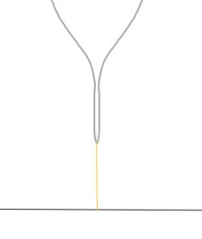
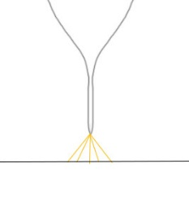
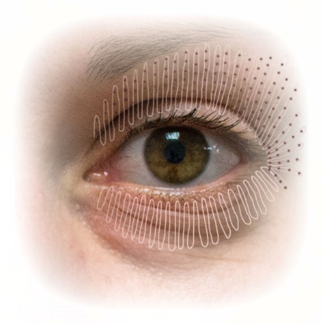
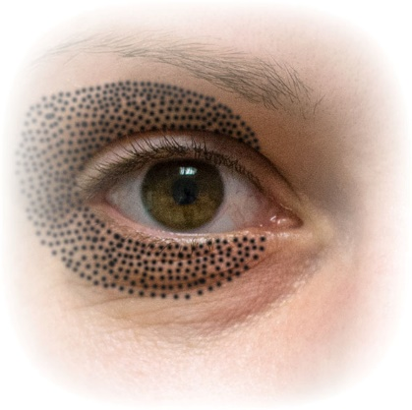
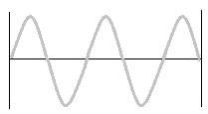
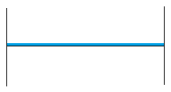
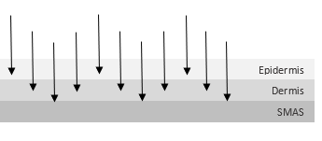
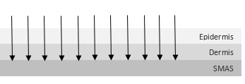
0.1mm²
3-4mm²
Size of discharge
Biomedicínská technika a bioinformatika
Scanning + dot by dot
Dot by dot only
PATENTED TECHNOLOGY!!!
OTHER DEVICES vs. JETT PLASMA

AC (Alternating current) DC (Direct current)

Biomedicínská technika a bioinformatika
Technology
N/A
N/A
Own R&D center, background with own doctors, clinics and science institutions, with many features
Biomedicínská technika a bioinformatika
R&D
Biomedicínská technika a bioinformatika
CE 1023 (EU), KFDA (South Korea), INMETRO (Brasil), Ukraine
In process: FDA (USA), CFDA (China), TFDA (Taiwan), Russia, COFEPRIS (Mexico), TGA (Australia), Belarus, Moldova, Kazachstan, Uzbekistan, Malaysia, Singapore, Indonesia, Israel, UAE, KSA (Saudi Arabia)
Worldwide
N/A
Biomedicínská technika a bioinformatika
Universal
Usually simple applicator
Biomedicínská technika a bioinformatika
Dermatology, ophthalmology, gynecology, in close future also proctology, stomatology, ORL
1. Medical golden applicator- for medical indications
2. Four cosmetic heads – for skin tightening & lifting
Diversity
Biomedicínská technika a bioinformatika
Usually nothing
Safety functions
1. Tape
2. Grounding
3. Automatic switch off
Biomedicínská technika a bioinformatika
Depth control
Biomedicínská technika a bioinformatika
Unique treatment method

