AFTER TREATMENT CARE FOR PATIENTS

- skin is disinfected by the doctor / therapist after the treatment.
- Immediately after treatment apply one of healing creams (e.g. “cica” cream) which contain panthenol and hyaluronic acid and are suitable to be applied to injured and irritated skin and accelerate reparation of epidermis.
- disinfect the treated area twice a day after washing for 7-10 days after the procedure and after that always apply healing cream. This procedure has to be repeated until the spontaneous separation of crusts.
- corrective cosmetics can only be used after healing of the epidermis / if necessary, Oxygenetix cover breathable products can be used.
- Patient has to avoid sunlight after surgery. If the skin is exposed to sun rays, it is necessary to apply sunscreen with SPF 50 +, have sunglasses and head cover.
- It is advisable to visit the doctor / therapist after one and two weeks after the procedure.

JETT serum Liftvital
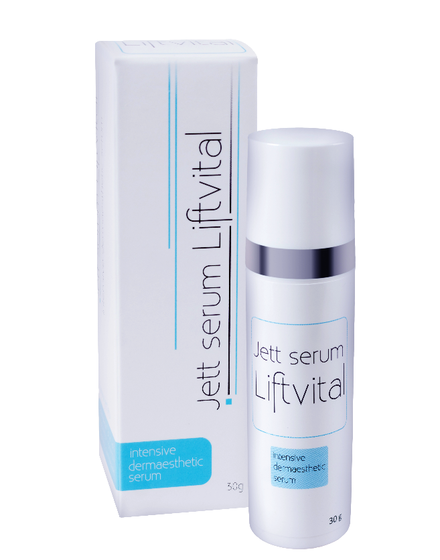
- After full healing of the skin, we recommend the use of hyalurono-glucomannan anti-aging Jett serum Liftvital for better skin regeneration after dermoesthetic procedures.

- The serum forms a protective film on the treated area, accelerates healing and long-term use increases the effect of non-surgical blepharoplasty treatment.

- Serum promotes hydration and normalization of the keratinocyte cell structure, strengthens cell proliferation, reduces unpleasant feelings in healing tissue.

- Jett serum Liftvital uses the synergy effects of individual substances: hyaluronic acid, vitamin C, glucomannan, alpha-oligoglucans, polysaccharides, D-panthenol and D-alpha-tocopherol.

Version
Aftercare 2019/01 ENG

