Non-surgical blepharoplasty

with JETT PLASMA LIFT MEDICAL

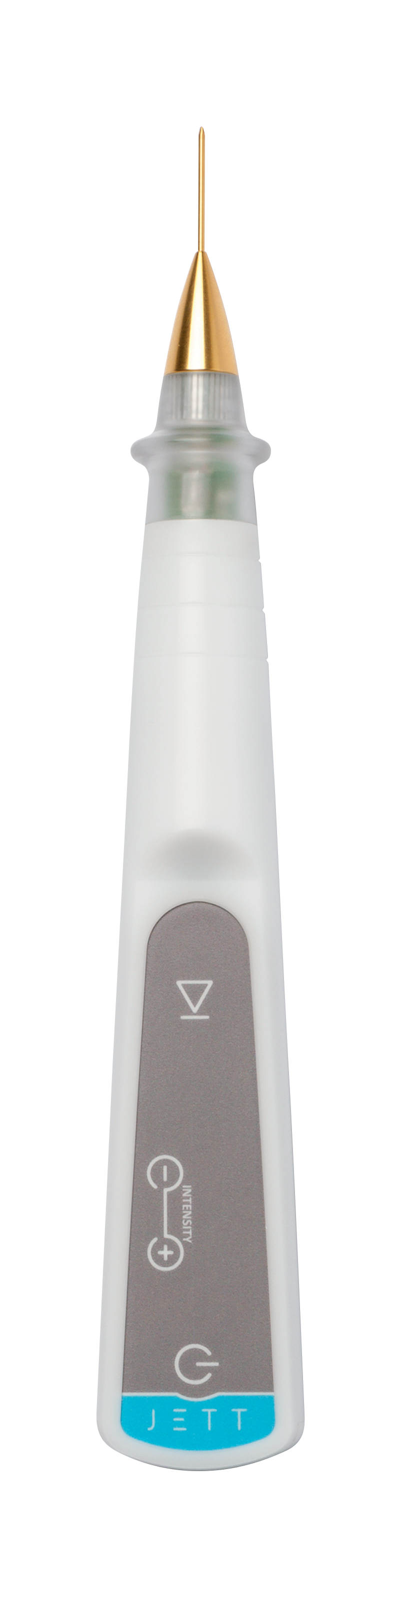

Version
Blepharoplasty 2019/01 ENG

BEFORE TREATMENT PROCEDURE

- The information on contraindications
- Inform yourself of any contraindications that would exclude treatment (pacemaker, Holter meter, other implanted electrical device, epilepsy, pregnancy, presence of metal substitutes at the treatment site) before the procedure. Complete list of contraindications is to be find in the operating manual.

- Eye area examination
- Evaluate the character of wrinkles and eyelids.
- Upper eyelids:
    - evaluate skin overhang,
    - In case of excessive skin overhang, consider whether surgical plastic treatment is preferable,
    - evaluate whether there is no roll of fat or strong permanent lymphoedema in the lid.
- Lower eyelids:
    - evaluate, whether they do not contain large amounts of fat,
    - if they are a lot droopy, it is reasonable to prefer plastic surgery.

- Disinfection, application of local anesthesia
- Removal of make-up
- Proper skin disinfection (since the JETT PLASMA LIFT MEDICAL works with electricity, we recommend a non-alcoholic disinfectant)
- Application of anesthesia by injection:
    - apply anesthesia by injection,
    - incorporate shallowly into the subcutaneous tissue (Supracain 4%, Mesocain 1%, Lidocaine, etc.),
    - use small needle (e.g. insulin needle), stay strictly subcutaneous but above muscle, avoid pricking tiny subcutaneous vessels, because of extensive hematomas,
    - start the application at the outer edge of the eye, every other injection insert always into the already insensitive skin. Continue to the inner edge of the eye,
    - after applying local anesthesia, wait 3-4 minutes for its effects.
- Application of anesthetic creams:
    - anesthetic creams may be used on sensitive areas of the face as well, but only with a high content of Lidocaine or combination of Lidocaine and Tetracaine (over 20%) etc.,
    - leave anesthetic cream for at least 20 minutes in occlusion.

TREATMENT PROCEDURE

- Setting up JETT PLASMA LIFT MEDICAL device
- Attach the golden ablative applicator to the device
- Plug the device into the electricity socket, message "TAPE" lights up on the display
- Attach the blue cable to the electrode, which then stick to the patient's skin – suitable is the back of the arm, where is much smaller irritation due to thicker skin
- According to the safety rules, now connect the blue cable to the device and avoid contact of the applicator with the patient's body and with the unprotected parts of our body
- After connecting both cables and sticking the electrode, the zero "-0-" number of the intensity lights up at the display

- Patient preparation
- Place the patient into horizontal position
- Check the position of head and lighting, which should be as comfortable as possible for the patient and for the physician
- Re-disinfect the skin with alcohol-free disinfection
- Wait about 1 minute before the treatment, until the disinfection evaporates

- Treatment
- Put on sterile gloves.
- Set a level of intensity on the device to 7 or 8. Selection of intensity depends on your subjective opinion. For better results use intensity 8, but in case you have a sensitive patient, select number 7.
- Get with the applicator closer to the skin. Once we are 4mm above the skin surface, the discharge appears.
- If you stay at the right distance from the skin, plasma discharge will be stable and continuous.

- The treatment begins at the upper eyelid under the eyebrows in the inner eye corner by the so-called SCANNING technique – it means that that we cross the discharge over the treated area and heat the skin
    - scan the skin quickly, place next to place
    - scan 8-10 mm wide strip of the eyelid just below the eyebrow from the inner to the outer corner of the eye, then scan another strip of the eyelid of the same width to align with the already scanned strip
    - proceed to the edge of the eyelid
    - the result of scanning is gray skin - this is about 3-7 minutes. Scan until erythema is visible (erythema in this context means warming / warming of the dermis, which causes tissue renewal, flexibility improvement and stimulation of immunity and tissue resistance)
    - If the skin is brown, there is a deeper burn, which is not desirable
    - after scanning the entire area of the eyelid, check whether there is no roughness in the skin or whether some wrinkles are uneven
    - If the skin is uneven, scan the area once again
- Afterwards choose whether you want to continue by SCANNING or DOT-BY-DOT technique in the area of the deepest wrinkles and skin roughness.
INTENSIVE SCANNING
      - Discharge is applied in the form of intensive scanning which means that we leave it in one place for a longer time than we did with the previous scanning.
      - Like this precisely scan the surface along the whole wrinkle and in the area of skin unevenness.
      - The result of intensive scanning should be gray-colored deep wrinkles.
DOT-BY-DOT TECHNOLOGY
      - Stay with the discharge for a maximum of 3 seconds at one point.
    - Make by the discharge linearly dots (points) across the entire upper eyelid area.

- After the upper eyelid treatment, move to the lower eyelid, where we perform only the SCANNING technique.
- When the lower eyelid is done, disconnect the blue grounding cable from JETT PLASMA device and remove the electrode from patient's body.

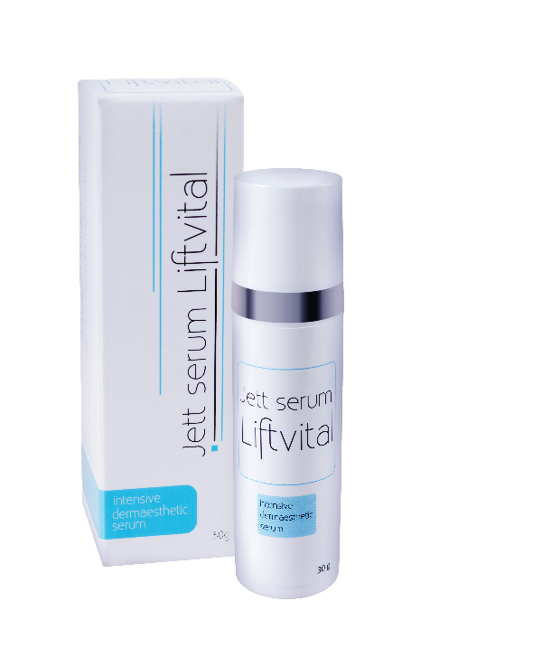
AFTER TREATMENT CARE
- Clean the skin with disinfection again after the treatment.
- Immediately after treatment apply one of healing creams (e.g. “cica” cream) which contain panthenol and hyaluronic acid and are suitable to be applied to injured and irritated skin and accelerate reparation of epidermis.
- Patient must be advised to disinfect the treated area twice a day after washing for 7-10 days after the procedure and after that always apply healing cream. This procedure has to be repeated until the spontaneous separation of crusts.
- Corrective cosmetics can only be used after healing of the epidermis.
- Patient has to avoid sunlight after surgery. If the skin is exposed to sun rays, it is necessary to apply sunscreen with SPF 50 +, have sunglasses and head cover.
- It is advisable to check the patient after one and two weeks after the procedure.
- After full healing of the skin, we recommend the use of hyalurono-glucomannan anti-aging Jett serum Liftvital for better skin regeneration after dermoesthetic procedures.
- The serum forms a protective film on the treated area, accelerates healing and long-term use increases the effect of non-surgical blepharoplasty treatment.
- Serum promotes hydration and normalization of the keratinocyte cell structure, strengthens cell proliferation, reduces unpleasant feelings in healing tissue.
- Jett serum Liftvital uses the synergy effects of individual substances: hyaluronic acid, vitamin C, glucomannan, alpha-oligoglucans, polysaccharides, D-panthenol and D-alpha-tocopherol.

RESULTS

Skin appearance after treatment:

2 – 3 days after treatment | Erythema, oedema, scab
4 days after treatment | Small erythema, none oedema, separating and peeling the scab
5 – 8 days after treatment | Area around eyes without scabs, without color difference, make-up can be applied, rejuvenation is visible and skin is tightened
3 months after treatment | In the skin is still Increased production of collagen

If the treatment is performed correctly according to the instructions, the patient should record the first results after one week. The skin is finer and brighter, wrinkles are starting to turn off.

Trauma in dermis caused by JETT PLASMA LIFT MEDICAL stimulates fibroblasts to produce new collagen and elastin fibers. The neocolagenesis and neolastigenesis process necessary for wrinkle smoothing lasts for about 1 month. For this reason, the final results are apparent after this time or even up to 3 months.

WHAT EFFECT CREATES DIRECT CURRENT IN THE SKIN?
- Significant increase in collagen type I
- Significant increase in content of intracellular Ca
- Significant increase in extracellular K
- Increase in chemotaxis
- Proven increase in migration of fibroblasts and their protheosythesis
- Skin permeability is increased
- The skin barrier function for the passage of positively charged ions or water-soluble compounds is reduced
- Reorientation of newly formed or formed collagen fibers in the direct current direction

FOR MORE INFORMATION AND TO SEE THE ILLUSTRATIVE VIDEOS, PLEASE VISIT OUR YOUTUBE CHANNEL

 | www.youtube.com/jettplasmadevices

BEFORE AND AFTER PHOTOS

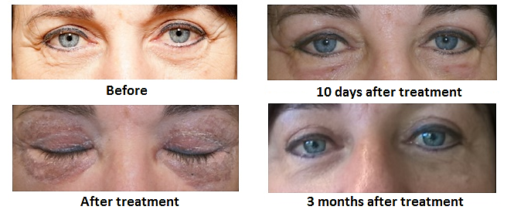

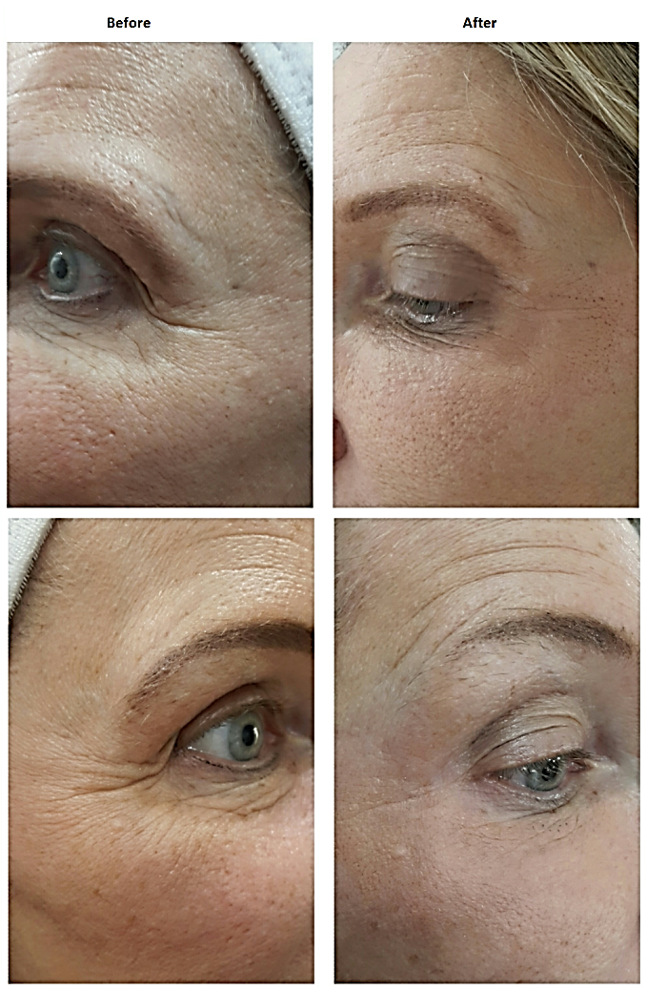

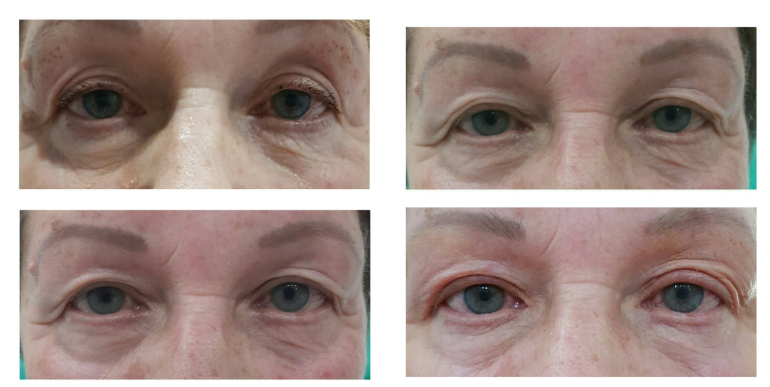

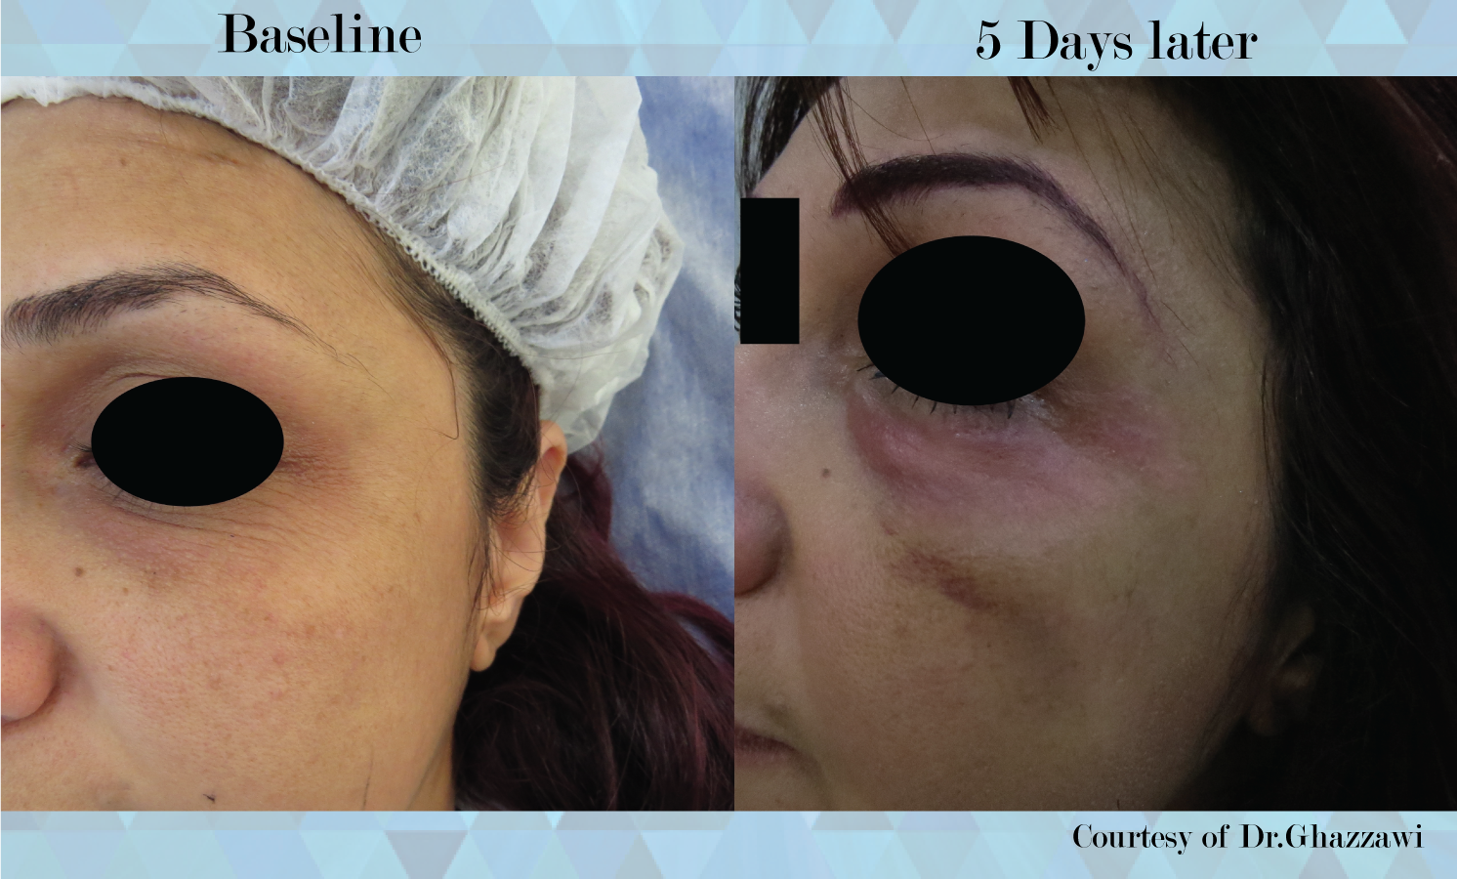

APPENDIX: EXPLANATION OF SCANNING AND SPOT TECHNIQUES

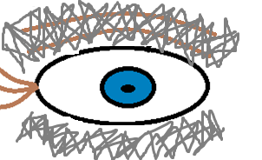
- SCANNING (what does „scanning“ mean?)
- Always scan the upper and lower eyelids.
- Treatment begins always at the upper eyelid under the eyebrow in the inner eye corner
- Scan quickly, place next to place.
- Scan 8-10 mm wide strip of the eyelid just below the eyebrow from the inner to the outer corner of the eye, then scan another strip of the eyelid of the same width to align with the already scanned strip.
- Proceed to the edge of the eyelid.
- The result of scanning is gray skin - this is about 3-7 minutes. Scan until erythema is visible (erythema in this context means warming / warming of the dermis, which causes tissue renewal, flexibility improvement and stimulation of immunity and tissue resistance).
- If the skin is brown, there is a deeper burn, which is not desirable.
- After scanning the entire area of the eyelid, check whether there is no roughness in the skin or whether some wrinkles are uneven.
- If the skin is uneven, scan the area once again.

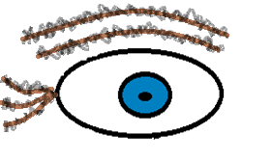
- INTENSIVE SCANNING
- Similar technique to scanning with the difference that we perform very fast scanning along individual wrinkles.

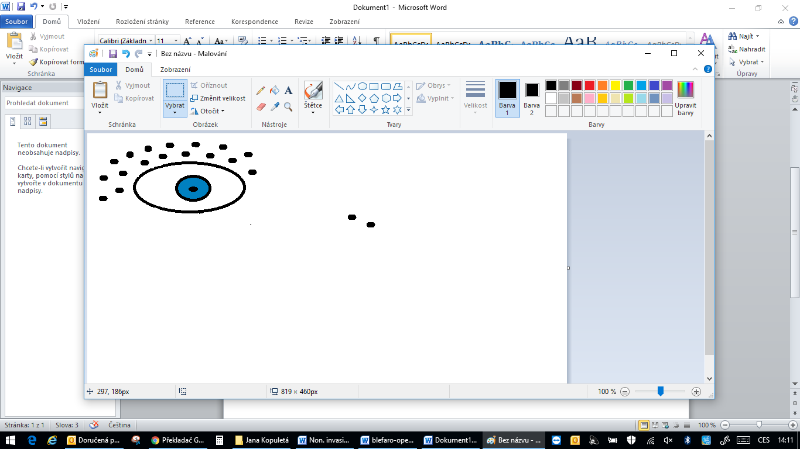
- DOT-BY-DOT technique (what means „dot-by-dot“?)
- Making (burning) many small dots in the distance of 2mm one from another.
- Like this we treat deep wrinkles.
- Stay with the discharge a tone spot for a maximum of 3 seconds.
- Plasma discharge cause trauma in dermis and contraction of collagen.
- Lower eye-lids should not be treated by dot-by-dot. The skin here is very thin and there is a risk of scarring.

