The removal of benign lesions
verruca, keratosis, fibroma, haemangioma, nevus

with JETT PLASMA LIFT MEDICAL

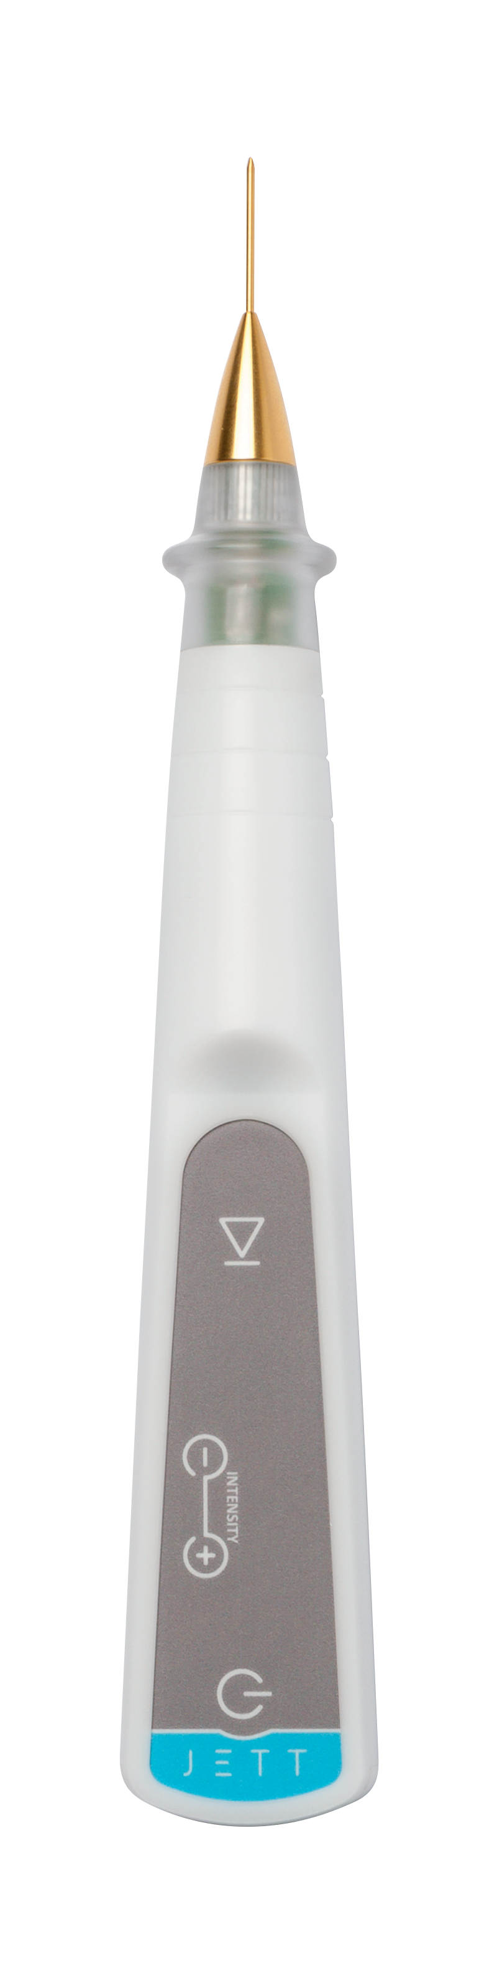

Version
Lesions 2019/01 ENG

Prior to the removal of the above listed diagnoses, it should be always evaluated whether they are the malign or pre-malign conditions of lesions or not. It is important to focus on a differential diagnosis of basaloma, squamous cell carcinoma and melanoma.

THE PRE-TREATMENT PROCEDURE

- The information on contraindications
- Before the treatment, you should be informed about possible contraindications that could exclude the treatment (pacemaker, Holter monitor, another implanted electrical device, epilepsy, pregnancy, metal implants in the treated area).

- The examination of a lesion
- Evaluate the character of affection;
- Check the skin condition;
- Then, include the patients with benign lesions which do not tend to become malignant, into the indicated conditions;
- If the benignity of a lesion cannot be defined exactly, we recommend biopsy before the treatment.

- The disinfection and the application of local anaesthesia
- Remove the make-up;
- Disinfect thoroughly the skin (with regard to the fact that JETT PLASMA LIFT MEDICAL works with electric energy, we recommend to use an alcohol-free disinfectant);
- Anaesthesia application:
    - In case of small lesions, apply anaesthesia in the form of the anaesthetic cream with a minimum content of 5% Lidocaine or Tetracaine (e.g.: Emla cream or Lidocaine gel);
    - Wait for the cream effect for minimum 20 minutes;
    - It is suitable to use occlusion to speed up the effect of anaesthesia (cover the applied cream with an airtight foil – plastic foil);
    - In case of larger lesions, apply the local anaesthesia in the form of an injection (Supracaine 4%, Mesocaine 1%, Lidocaine, etc.)

THE TREATMENT PROCEDURE

- The setting of JETT PLASMA LIFT MEDICAL
- Select a golden pointed head for the treatment and fit it on the device;
- Plug in the device. The message “TAPE” will light up on the display;
- Connect a blue cable to the electrode and stick it on the patient´s skin – the back side of the upper arm is suitable where the possible irritation of skin is much smaller thanks to a thicker skin;
- According to safety rules, connect the blue cable to the device only now to avoid any contact of the fitted head with the patient´s body and unprotected parts of your body;
- Having connected both cables and having stuck the electrode, the message “-0-“ will appear.

- The preparation of a patient
- Check the position of the body part with a lesion and the lighting which should be most comfortable both for the patient and the doctor;
- Disinfect again the skin using an alcohol-free disinfectant;
- Wait roughly 1 minute prior to start the treatment until the disinfection is evaporated.

- Treatment
- Put on a pair of sterile gloves;
- Set the intensity 7 – 8 on the device (the selection of an intensity degree depends on your subjective consideration. Select 8 for better results and 7 for a more sensitive patient);
- Get closer to the patient´s skin with the head tip and as soon as you get to 4 mm above the skin surface, the spark discharge will ignite ;
- If the tip of the head remains in a correct height above the skin, the plasma discharge will be continuous;
- Remove the lesion by evaporating gradually the affection by layers which carbonise (they are getting black);
- This is achieved by the so-called SCANNING technique. It consists in scanning the treated area with a discharge thereby the skin is warmed up;
- Always wipe away the carbonised layer with cellulose pads with physiological solution or disinfecting solution (free of spirit!!!).
- Proceed by layers until the skin level.
- Never get under the skin level; otherwise, it would create a minor scar.
- You should always take into consideration that local anaesthesia will cause skin deformation and warming-up of the skin will cause oedema in the place of application;
- Disconnect the blue cable from the device and unstick the electrode from the patient´s skin.

AFTER-TREATMENT THERAPY
- After the treatment, clean the skin with a disinfectant and cover it by a plaster as the case may be. (Keep the plaster maximum until the evening). By no means may you apply common corrective cosmetics.
- The skin can be washed up in the evening after the removal;
- Disinfect the treated places two times a day for 2 – 3 days after the treatment;
- After disinfection, it is suitable to apply a special regeneration gel containing hyaluronic acid twice a day for the next 5 – 7 days.
- After the regeneration gel dries up (approx. 10 min.), corrective cosmetics (make-up) can be applied on the skin;
- Protect the skin from solar radiation by applying the creams with SPF 50+ and sun glasses and head cover for a minimum of 7-10 days after the treatment;
- We recommend seeing the doctor after the second week.

RESULTS

The skin appearance after the treatment:

2 – 3 days after the treatment | Small scabs (seldom erythema, oedema)
4 days after the treatment | Small scabs start to peel off (without any erythema, without any oedema)
5 – 8 after the treatment | Now, the skin is without any small scabs and without any colour changes. Make-up can be applied in this phase. Rejuvenation is visible.  To support healing, we recommend to apply LiftVital serum two times a day for the period of 14 days.

If the treatment was performed correctly according to the instructions, the lesion should be removed immediately. Or perhaps a carbonised layer may remain on the skin – a small scab, which will sequestrate within several days.
Healing takes usually one week. In extraordinary cases, it may take a longer time. If a larger lesion was removed, its healing may last up to 14 days.

FOR MORE INFORMATION AND TO SEE THE ILLUSTRATIVE VIDEOS, PLEASE VISIT OUR YOUTUBE CHANNEL

 | www.youtube.com/jettplasmadevices

THE PHOTOGRAPHS BEFORE AND AFTER TREATMENT

The following patients were treated with JETT PLASMA LIFT MEDICAL and the change of their skin appearance was gradually documented.

Before treatment A week after treatment
