The removal of bordered pigmentations
melasma (chloasma), lentigo simplex

with JETT PLASMA LIFT MEDICAL

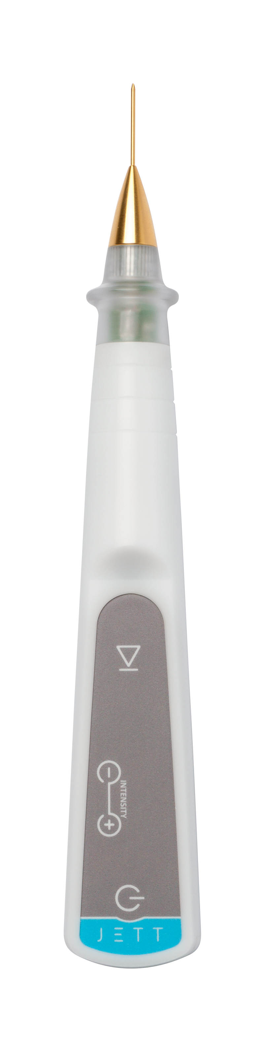

Version
Pigmentation 2019/01 ENG

It should be first evaluated, whether it is really pigmentation and not any inflammatory change of skin colour or another skin disorder.
Check, whether they are the malign or pre-malign conditions of lesions or not. It is important to focus on a differential diagnosis of basaloma, squamous cell carcinoma and melanoma.

THE PRE-TREATMENT PROCEDURE

- The information on contraindications
- Before the treatment, you should be informed about possible contraindications that could exclude the treatment (pacemaker, Holter monitor, another implanted electrical device, epilepsy, pregnancy, metal implants in the treated area).

- The examination of a lesion
- Evaluate the character of affection;
- Check the skin condition;
- Then, include the patients with pigmentations into the indicated conditions.

- The disinfection and the application of local anaesthesia
- Remove the make-up;
- Disinfect thoroughly the skin (with regard to the fact that JETT PLASMA LIFT MEDICAL works with electric energy, we recommend to use an alcohol-free disinfectant);
- Anaesthesia application:
- In case of small lesions, apply anaesthesia in the form of the anaesthetic cream with a minimum content of 5% Lidocaine or Tetracaine (e.g.: Emla cream or Lidocaine gel);
- Wait for the cream effect for minimum 20 minutes;
- It is suitable to use occlusion to speed up the effect of anaesthesia (cover the applied cream with an airtight foil – plastic foil);
- In case of larger lesions, apply the local anaesthesia in the form of an injection (Supracaine 4%, Mesocaine 1%, Lidocaine, etc.)

THE TREATMENT PROCEDURE

- The setting of JETT PLASMA LIFT MEDICAL
- Select a golden pointed head for the treatment and fit it on the device;
- Plug in the device. The message “TAPE” will light up on the display;
- Connect a blue cable to the electrode and stick it on the patient´s skin – the back side of the upper arm is suitable where the possible irritation of skin is much smaller thanks to a thicker skin;
- According to safety rules, connect the blue cable to the device only now to avoid any contact of the fitted head with the patient´s body and unprotected parts of your body;
- Having connected both cables and having stuck the electrode, the message “-0-“ will appear.

- The preparation of a patient
- Check the position of the body part with a lesion and the lighting which should be most comfortable both for the patient and the doctor;
- Disinfect again the skin using an alcohol-free disinfectant;
- Wait roughly 1 minute prior to start the treatment until the disinfection is evaporated.

- Treatment
- Put on a pair of sterile gloves;
- Set the intensity 6 – 8 on the device (the selection of an intensity degree depends on your subjective consideration. Select 8 for better results and 6 or 7 for a more sensitive patient);
- Get closer to the patient´s skin with the head tip and as soon as you get to 4 mm above the skin surface, the spark discharge will ignite;
- If the tip of the head remains in a correct height above the skin, the plasma discharge will be continuous;
- Remove the pigmentation by scanning gradually its whole area place by place;
- Always wipe away the carbonised layer with cellulose pads with physiological solution or disinfecting solution (free of spirit!!!).
- If the pigmentation persists, repeat the whole procedure - the point is that it cannot be presumed if the pigmentation is only epidermal or also dermal.
- After the treatment, disinfect thoroughly the whole treated area.
- Disconnect the blue cable from the device and unstick the electrode from the patient´s skin.

AFTER-TREATMENT THERAPY
- After the treatment, clean the skin with a disinfectant and cover it by a plaster as the case may be. (Keep the plaster maximum until the evening). By no means may you apply common corrective cosmetics.
- The skin can be washed up in the evening after the removal;
- Disinfect the treated places two times a day for 2 – 3 days after the treatment;
- After disinfection, it is suitable to apply a special regeneration gel containing hyaluronic acid above 1 % intended for an injured skin twice a day for the next 5 – 7 days;
- After the regeneration gel dries up (approx. 10 min.), corrective cosmetics (make-up) can be applied on the skin;
- Protect the skin from solar radiation by applying the creams with SPF 50+ and sun glasses and head cover for a minimum of 7-10 days after the treatment;
- We recommend seeing the doctor after a week.

RESULTS

The skin appearance after the treatment:

2 – 3 days after the treatment | Small scabs (seldom erythema, oedema)
4 days after the treatment | Small scabs start to peel off (without any erythema, without any oedema)
5 – 8 days after the treatment | Now, the skin is without any small scabs and without any colour changes. Make-up can be applied in this phase. Rejuvenation is visible  To support healing, we recommend to apply LiftVital serum two times a day for the period of 14 days

If the treatment was performed correctly according to the instructions, the pigmentation should be removed immediately. Or perhaps a carbonised layer may remain on the skin – a small scab, which will sequestrate within several days.
Healing takes usually one week. In extraordinary cases, it may take a longer time. If a larger lesion was removed, its healing may last up to 14 days.

FOR MORE INFORMATION AND TO SEE THE ILLUSTRATIVE VIDEOS, PLEASE VISIT OUR YOUTUBE CHANNEL

 | www.youtube.com/jettplasmadevices

