The removal of atrophic, hypertrophic and keloid scars

with JETT PLASMA LIFT MEDICAL

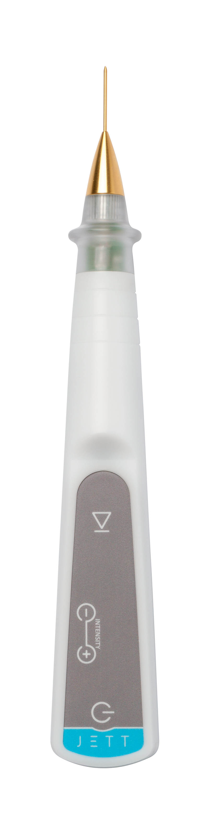

Version
Scars 2019/01 ENG

The type of scars should always be evaluated.

We distinguish the following types of scars:
- Atrophic, sunken under the skin level, e.g. scars after acne;
- Hypertrophic, raised above the surrounding epidermis. They are harder than the surrounding tissue, however they do not extend beyond the boundary of trauma;
- Keloid, overgrowing markedly the surrounding area, hard, shiny and whitish, extending beyond the boundary of trauma.

Never treat fresh scars. They can be treated first after two months from the injury.
Recommend your client to apply a silicon sheet or ointment to fresh scars at night on a long-term basis.

THE PRE-TREATMENT PROCEDURE

- The information on contraindications
- Before the treatment, you should be informed about possible contraindications that could exclude the treatment (pacemaker, Holter monitor, another implanted electrical device, epilepsy, pregnancy, metal implants in the treated area).

- The examination of a lesion
- Evaluate the scar character;
- Check the skin condition.

- The disinfection and the application of local anaesthesia
- Remove the make-up
- Disinfect thoroughly the skin (with regard to the fact that JETT PLASMA LIFT MEDICAL works with electric energy, we recommend to use an alcohol-free disinfectant)
- Anaesthesia application:
    - In case of small lesions, apply anaesthesia in the form of the anaesthetic cream with a minimum content of 5% Lidocaine or Tetracaine (e.g.: Emla cream or Lidocaine gel);
    - Wait for the cream effect for minimum 20 minutes;
    - It is suitable to use occlusion to speed up the effect of anaesthesia (cover the applied cream with an airtight foil – plastic foil);
    - In case of larger lesions, apply the local anaesthesia in the form of an injection (Supracaine 4%, Mesocaine 1%, Lidocaine, etc.).

THE TREATMENT PROCEDURE

- The setting of JETT PLASMA LIFT MEDICAL
- Select a golden pointed head for the treatment and fit it on the device;
- Plug in the device. The message “TAPE” will light up on the display;
- Connect a blue cable to the electrode and stick it on the patient´s skin – the back side of the upper arm is suitable where the possible irritation of skin is much smaller thanks to a thicker skin;
- According to safety rules, connect the blue cable to the device only now to avoid any contact of the fitted head with the patient´s body and unprotected parts of your body;
- Having connected both cables and having stuck the electrode, the message “-0-“ will appear.

- The preparation of a patient
- Check the position of the body part with a lesion and the lighting which should be most comfortable both for the patient and the doctor;
- Disinfect again the skin using an alcohol-free disinfectant;
- Wait roughly 1 minute prior to start the treatment until the disinfection is evaporated.

- Treatment
- Put on a pair of sterile gloves;
- Set the intensity 6 – 8 on the device (the selection of an intensity degree depends on your subjective consideration. Select 8 for better results and 6 or 7 for a more sensitive patient);
- Get closer to the patient´s skin with the head tip and as soon as you get to 4 m above the skin surface, the spark discharge will ignite;
- If the tip of the head remains in a correct height above the skin, the plasma discharge will be continuous.

ATROPHIC SCARS
    - Treat the atrophic scar by scanning the whole area of the scar so as to have the area grey (not brown!!!).
HYPERTROPHIC AND KELOID SCARS
Note: In case of keloid scars, we recommend to treat first only a small area of approximately 2 x 2 mm as a trial and to evaluate the application effect after 3 – 4 weeks. Some keloid scars react to minor traumata (which is even the treatment of a small area), others react by further growing of ligament and hypertrophy and those are not suitable for Plasma treatment.
    - Treat the hypertrophic and keloid scars by layers so as to have the surface brown to black.
    - Always wipe away the carbonised layer with cellulose pads with physiological solution or disinfecting solution (free of spirit!!!).

- You should always check what layer you have removed – it is necessary to treat the whole scar and to avoid getting under the level of the surrounding skin and causing thus any defect in the skin;
- We recommend to burn out the scar to only 1 – 2 mm above the level of the surrounding skin during the first treatment;
- You should keep in mind that the plasma application causes oedema in the place of application due to high temperature;
- The scar can be next treated after 14 days and levelled out to the surrounding skin.

- After the end of the treatment, disinfect thoroughly the whole treated area;
- Disconnect the blue cable from the device and unstick the electrode from the patient s skin.

AFTER-TREATMENT THERAPY
- After the treatment, clean the skin with a disinfectant and cover it by a plaster as the case may be. (Keep the plaster maximum until the evening). By no means may you apply common corrective cosmetics.
- The skin can be washed up in the evening after the removal;
- Disinfect the treated places two times a day for 2 – 3 days after the treatment;
- After disinfection, it is suitable to apply a special regeneration gel containing hyaluronic acid above 1 % intended for an injured skin twice a day for more 5 – 7 days;
- After the week, grease the skin thoroughly with creams to prevent the crust from preliminary pulling-off;
- Protect the skin from solar radiation by applying the creams with SPF 50+ and sun glasses and head cover for a minimum of 7-10 days after the treatment;
- We recommend seeing the doctor after a week.

RESULTS

The skin appearance after the treatment:

2 – 3 days after the treatment | Small scabs (seldom erythema, oedema)
4 days after the treatment | Small scabs start to peel off (without any erythema, without any oedema)
5 – 8 after the treatment | Now, the skin is without any small scabs and without any colour changes. Make-up can be applied in this phase. Rejuvenation is visible.  To support healing, we recommend to apply LiftVital serum two times a day for the period of 14 days.

If the treatment was performed correctly according to the instructions, the scar should be removed after two sessions at the latest.

During the first treatment, the scar is burned only to the level of approximately 1 – 2 mm above the level of the surrounding skin. After 14 days, the second treatment will level the scar to the surrounding skin.

Healing takes usually one week. In extraordinary cases, it may take a longer time. If larger lesion was removed, its healing may last up to 14 days.

FOR MORE INFORMATION AND TO SEE THE ILLUSTRATIVE VIDEOS, PLEASE VISIT OUR YOUTUBE CHANNEL

 | www.youtube.com/jettplasmadevices

THE PHOTOGRAPHS BEFORE AND AFTER TREATMENT

The following patients were treated with JETT PLASMA LIFT MEDICAL and the change of their skin appearance was gradually documented.

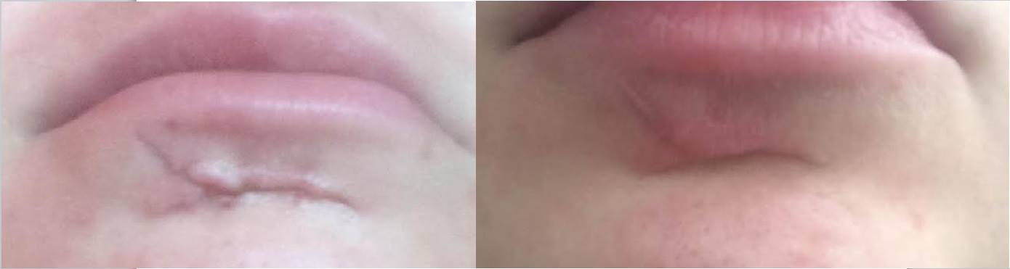
Before treatment One month after 2nd treatment

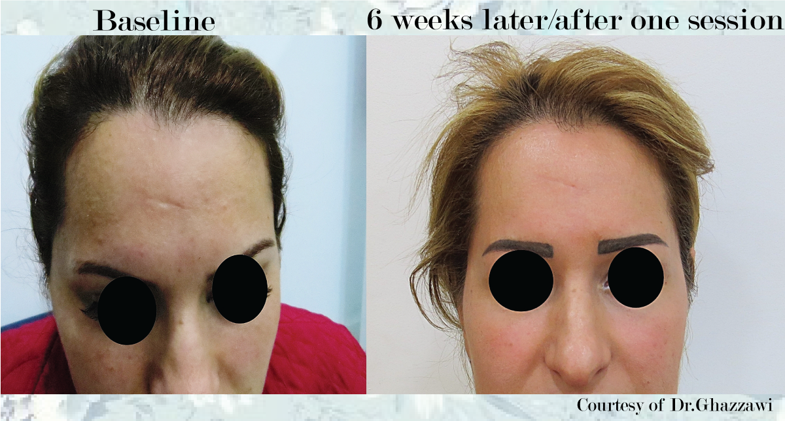

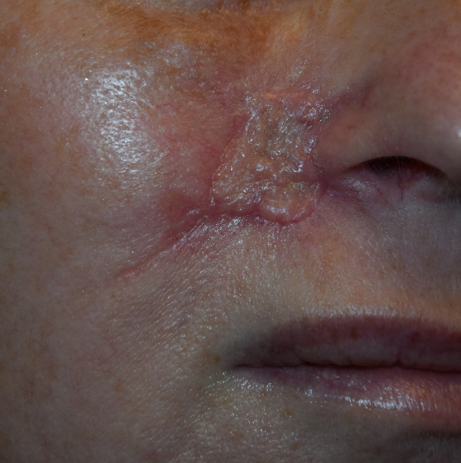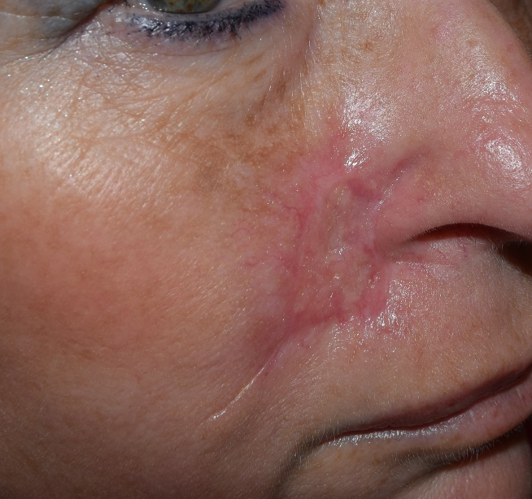
Before treatment 14 days after 1st treatment

