Treatment of Blepharitis

with JETT PLASMA LIFT MEDICAL
silver applicator

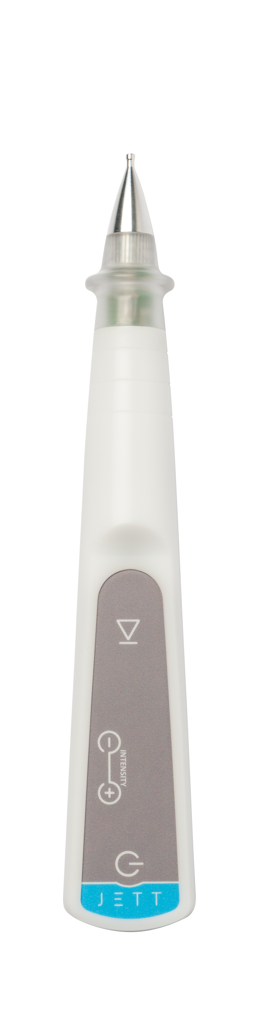

Version
JPLM Blepharitis 2019/01

PRE-TREATMENT PROCEDURE

- Pre-treatment information

  - Provision of information to the patient

- The first step of the performed treatment is to acquaint the patient with the treatment procedure. A nurse, together with a doctor, explains under which conditions and circumstances the treatment will be executed. In other words, the patient should be informed clearly why the planned treatment is necessary, which day and time he/she should come, in what manner the treatment will be executed, what are the risks of the treatment, that he/she should not come hungry and thirsty, whether he/she should be accompanied by somebody to assist him/her on the way home, for how long the convalescence will last, whether the incapacity for work will follow, etc. It is also important to advice the patient on the need to keep the prescribed drug dosages which he/she routinely administers (medicines for high blood pressure, thyroid gland, etc.) and, simultaneously, on the need to discontinue or adjust some drug dosages (Warfarin, Anopyrin etc.).

  - The examination of malfunction

- Evaluate the character of affection and make photo-documentation

  - Contraindication information
Prior to the treatment, inform the patient about contingent contraindications, which would exclude the treatment, like:
- Peacemaker, Holter ECG monitoring system;
- Another implanted electrical device;
- Epilepsy;
- Pregnancy;
- Metal implants in the treated area;
- Skin diseases, skin inflammations;
- Acute inflammatory disease;
- Any untreated/badly treated disease;
- Oncological disease;
- Allergy to local anaesthetics;
- Allergy to disinfectants.

- Patient preparation for the treatment (disinfection, local anaesthesia)
- Standard pre-operation preparation takes place at the operating room. Remove the make-up and disinfect thoroughly the skin (with regard to the fact that JETT PLASMA LIFT MEDICAL works with electric power, alcohol-free disinfectant is recommended) and cover it with operation cloth.
- Within the pre-operation treatment, you could apply BENOXI, 4MG/ML OPH GTT SOL (Lidocaine Eye Drops) two times every three minutes.

TREATMENT PROCEDURE

- Setting of JETT PLASMA LIFT MEDICAL

- For this treatment, select a silver flat applicator 3 mm.
- Plug in the device. A message “TAPE” will light up on the display.
- Connect the curly connection cable to disposable electrode and stick it on the patient´s skin – the inner side of forearm is suitable where there is no hair, the patient can only roll up the sleeve and it is more comfortable in the out-patient department, or the back side of upper arm where a contingent skin irritation is much smaller thanks to a thicker skin, or insert a cylinder electrode into the patient´s hand to be kept firmly during the whole treatment procedure.
- Only now, according to safety rules, connect the curly connection cable to the device. This will exclude any contact between the put-on applicator and the patient´s body and unprotected body parts.
- After the connection of both cables and sticking a disposable electrode on the skin or pressing the cylinder electrode, the mark “-1-“ will light up on the display.

- Patient preparation

- Check the lighting and patient position, which should be most comfortable both for the patient and for the doctor.
- Disinfect once more the skin with an alcohol-free disinfectant.
- Prior to starting the treatment, wait roughly 1 minute until the disinfectant evaporates.
- Prior to starting the treatment it is necessary to aply a gel on the lid to be treated (Recugel, Vidisic) to ensure perfect contact of the mucosa with the applicator.

- Treatment

- Put on sterile gloves.
- Set the intensity degree 1, during the treatment the intensity can be increased based on patient comfort (up to intensity 5).
- Using an operating microscope, evert the lower eyelid and attach the silver applicator to the eyelid mucosua. Only when the applicator is attached to the lid or torsal conjunctiva the direct current can be turned on by touch button on JPLM or by pressing the button on Plasma Pen.
- Immediately after the direct current is turned on, the silver head moves in the lubricating gel in the tertiary conjunctiva and lid margin. Movement is continuous slowly. The time of the treatment takes about one minute.
- The procedure of the upper eyelid treatment is similar. The patient has to have his head bent back. Again, evert the upper eyelid and proceed in the same way as in the case of the lower eyelid.
- After treatment stop the direct current and then delay the applicator from the eyelid.
- Disconnect the curly connection cable from the device, unstick the disposable electrode from the patient´s body or the cylinder electrode is handed over to the healthcare person.

AFTER-TREATMENT CARE

- After the treatment, clean the eyelid and apply teardrop after treatment (for example Protectum Sensitive).
- Advice the patient on the hygiene of eyelids and the massage of Meibomian glands.
- It is important to protect eyes and the skin around them from solar radiation using creams of SPF 50+ and wearing sunglasses and head cover for minimum 14 days from the treatment.

CHECK-UPS

The first medical check-up is after 14 days after the treatment when the patient is able to tell objectively whether the condition has improved/worsened/is unchanged. If the treatment is insufficient, the whole treatment is repeated after 4 to 6 weeks. The last check-up is 3 months after the last treatment where photo-documentation is made and recurrence is excluded.

