Treatment of Trichiasis and Distichiasis

with JETT PLASMA LIFT MEDICAL

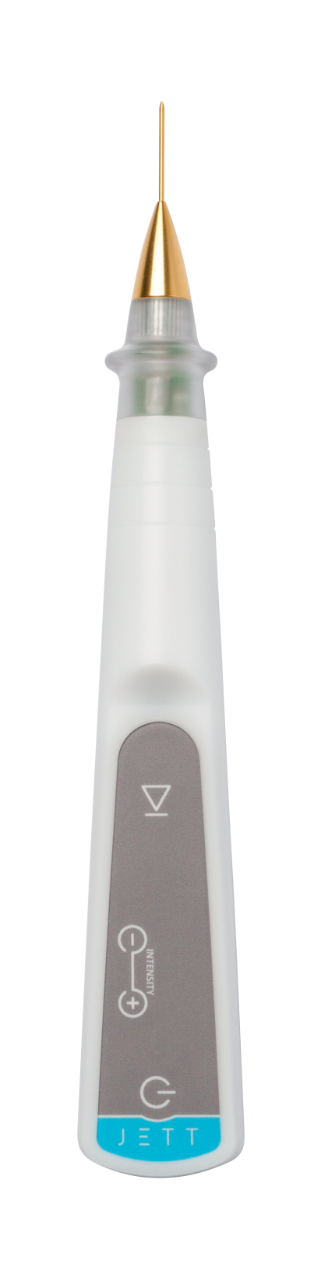

Verze
JPLM Trichiasis and Distichiasis 2019/01

PRE-TREATMENT PROCEDURE

- Pre-treatment information

  - Provision of information to the patient

- The first step of the performed treatment is to acquaint the patient with the treatment procedure. A nurse, together with a doctor, explains under which conditions and circumstances the treatment will be executed. In other words, the patient should be informed clearly why the planned treatment is necessary, which day and time he/she should come, in what manner the treatment will be executed, what are the risks of the treatment, that he/she should not come hungry and thirsty, whether he/she should be accompanied by somebody to assist him/her on the way home, for how long the convalescence will last, whether the incapacity for work will follow, etc. It is also important to advice the patient on the need to keep the prescribed drug dosages which he/she routinely administers (medicines for high blood pressure, thyroid gland, etc.) and, simultaneously, on the need to discontinue or adjust some drug dosages (Warfarin, Anopyrin etc.).

  - The examination of malfunction

- Evaluate the character of affection and make photo-documentation

  - Contraindication information
Prior to the treatment, inform the patient about contingent contraindications, which would exclude the treatment, like:
    - Pacemaker, ECG Holter monitor;
    - Another implanted electrical device;
    - Epilepsy;
    - Pregnancy;
    - Metal implants present in the treated area;
    - Skin disease, inflamed skin;
    - Acute inflammatory disease;
    - No/slightly cured disease;
    - Oncological disease;
    - Allergy to local anaesthetics;
    - Allergy to disinfectants.

- Patient preparation for the treatment (disinfection, local anaesthesia)
- Standard pre-operation preparation takes place at the operating room. Remove the make-up and and apply Benoxi gtt into both eyes. Disinfect thoroughly the skin (with regard to the fact that JETT PLASMA LIFT MEDICAL works with electric power, alcohol-free disinfectant is recommended) and cover it with operation cloths.
- Within the pre-operation treatment, you could apply a cream containing lidocaine on eyelids in occlusion in order to increase the patient comfort. Wait for minimum 20 minutes for the cream effect.
- Apply the local anaesthetic according to your routine practice at your workplace (Supracaine 4%, Mesocaine 1%, Lidocaine, Mepivastesin, Ubivastesin, etc.). Apply it always using a 1-ml insulin syringe.

TREATMENT PROCEDURE

- Setting of JETT PLASMA LIFT MEDICAL

- For this treatment, select an ophthalmological applicator (golden 14.4/24.4 mm) to be put on Plasma Pen or select directly the golden head to be screwed directly in the device instead of Plasma Pen.
- Plug in the device. A message “TAPE” will light up on the display.
- Connect the stranded interconnecting cable to a self-adhesive electrode and stick it on the patient´s skin – the inner side of forearm is suitable where there is no hair, the patient can only roll up the sleeve and it is more comfortable in the out-patient department, or the back side of upper arm where a contingent skin irritation is much smaller thanks to a thicker skin, or insert a cylindrical electrode into the patient´s hand to be kept firmly during the whole treatment procedure.
- Only now, according to safety rules, connect the stranded interconnecting cable to the device. This will exclude any contact between the put-on applicator and the patient´s body and unprotected body parts.
- After the connection of both cables and sticking a self-adhesive electrode on the skin or pressing the cylindrical electrode, the mark “-1-“ will light up on the display.

- Patient preparation

- Check the position of the body part with a lesion and lighting, which should be most comfortable both for the patient and for the doctor.
- Disinfect once more the skin with an alcohol-free disinfectant.
- Prior to starting the treatment, wait roughly 1 minute until the disinfectant evaporates.
- It should be emphasised that it is necessary to cover the proper globe as well. The smoke from evaporation and the discharge itself are unpleasant; if the globe is not covered, it could cause a painful burn of cornea.

- Treatment

- Put on sterile gloves.
- Set the device intensity degree 6, to avoid the burn of eyelid margin. The intensity degree selection depends upon the subjective consideration of the doctor. To achieve better results, the intensity degree can be set gradually up to 8. Evert the eyelid and, using a slit lamp, insert the ophthalmological applicator tip into the hair duct as deep as possible and then switch the device for 1 – 2 seconds. This will destroy the hair follicle.
- Disconnect the stranded interconnecting cable from the device, unstick the self-adhesive electrode from the patient´s body or the cylindrical electrode is handed over to the healthcare person.

AFTER-TREATMENT CARE

- After the treatment completion, apply Maxitrol ung.
- It is important to protect eyes and the skin around them from solar radiation using creams of SPF 50+ and wearing sunglasses and head cover for minimum 10 days after the treatment.

RESULTS

2–3 days | Small scabs (rarely erythema, oedema). Seldom slight hypopigmentation and slight lid notching)
4 days | The scabs start to peel off (without any erythema, oedema).
5–8 days | The skin is without any scabs, without any colour changes; visible rejuvenation.

A contingent skin deformation should always be considered as a result of local anaesthetic and oedema as a result of skin warming in the site of application.

CHECK-UPS

The first medical check-up is after 2 weeks against the photo-documentation when the patient is able to tell objectively whether the condition has improved/worsened/is unchanged. The last check-up is 3 months after the last treatment where photo-documentation is made and recurrence is excluded.

FOR MORE INFORMATION AND TO SEE THE ILLUSTRATIVE VIDEOS, PLEASE VISIT OUR YOUTUBE CHANNEL

 | www.youtube.com/jettplasmadevices

