
Order form
Ophthalmology
Company name:
Order date:
DEVICES & EXTENSIONS
Product name | Qty | Remark
OPHTHALMOLOGY SET
JETT PLASMA LIFT MEDICAL device
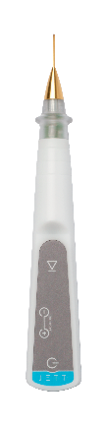
JETT Plasma Pen extension
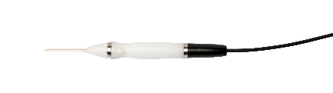
Ophthalmology applicators set
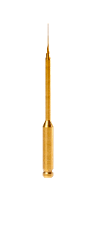
Metal Stand

JETT Plasma Pen extension
For JETT PLASMA LIFT MEDICAL
ACCESSORIES & OTHERS
JETT serum Liftvital 30 ml
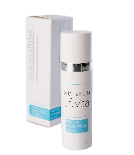
JETT serum Liftvital 400 ml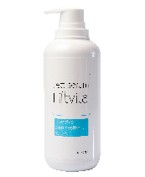
Stand for device
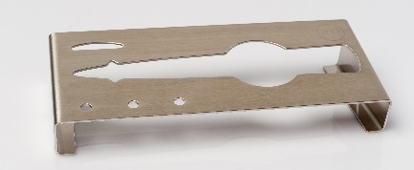
Stand for device
with Plasma Pen extension
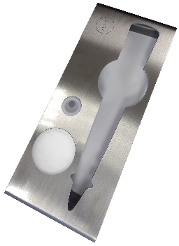
HUREV electrodes (4 pcs)
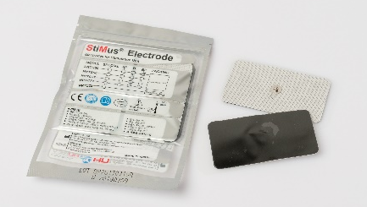
Cylinder electrode
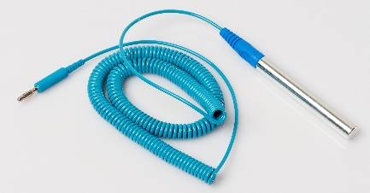
Network adapter
with relevant end piece
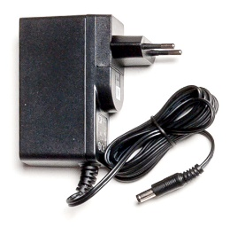
Extension cable
for network adapter
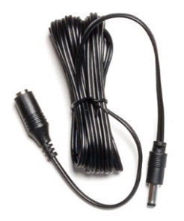
Curly connection cable
for disposable electrodes
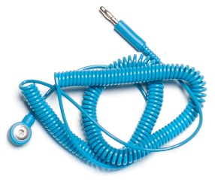
JETT PLASMA maquette
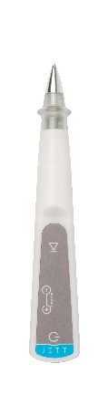
Applicators attached to the main body of the device
Golden applicator

Flat applicator

Flat applicator, diameter 3 mm

Flat applicator, diameter 5 mm

Cone applicator

Isolated applicators set
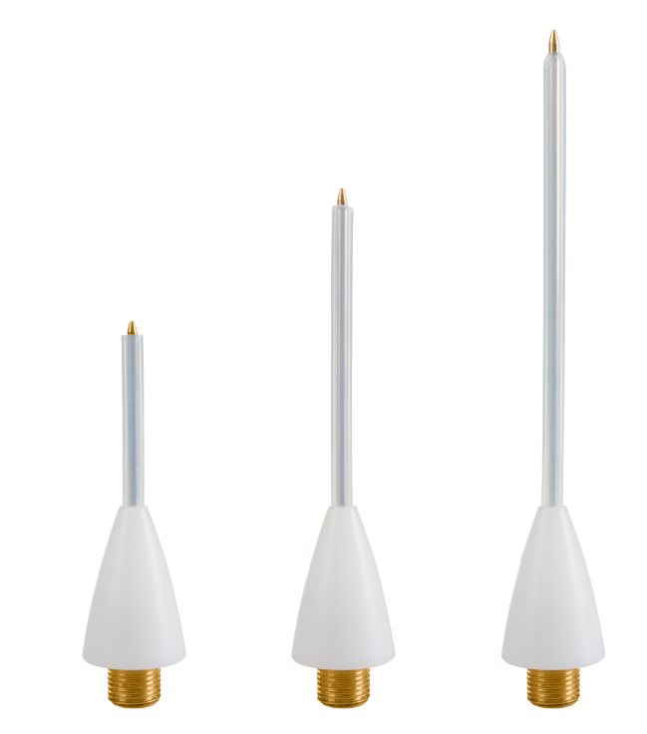
Applicators attached to the PLASMA PEN extension
Ophthalmology applicators set (5pcs)
For JETT Plasma Pen extension
Golden applicator 14,4 mm
For JETT Plasma Pen extension

Golden applicator 24,4 mm
For JETT Plasma Pen extension

Cone applicator
For JETT Plasma Pen extension

Flat applicator, diameter 3 mm
For JETT Plasma Pen extension

Flat applicator, diameter 5 mm
For JETT Plasma Pen extension

Flat applicator, diameter 10 mm
For JETT Plasma Pen extension

Flat applicator, diameter 20 mm
For JETT Plasma Pen extension
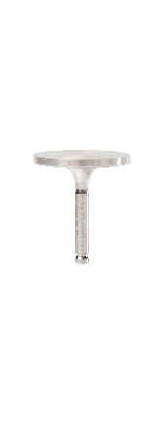
Isolated applicator L44
For JETT Plasma Pen extension

Isolated applicator L64
For JETT Plasma Pen extension


